U1.Assignment1: INTRODUCTION TO MARKUP LANGUAGES

Search on the Internet for the answer to the following questions:

1. What is a Markup Language? Find a picture that describes it.

A markup language is a computer language that uses tags to define elements within a document. It is human-readable, meaning markup files contain standard words, rather than typical programming syntax.

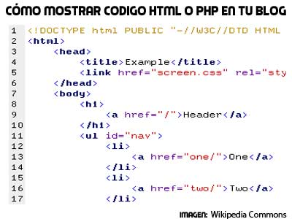

A markup language is a system for annotating a document in a way that is visually distinguishable from the content. It is used only to format the text, so that when the document is processed for display, the markup language does not appear.

1. Differences between a programming language and a markup language. Build a table for comparing these two different types of languages

|  |  |
| --- | --- |
| Markup Language | Programming Language |
| Works without Operating Systems | Works with Operating Systems |
| Is interpreted by the browser | Compiled by a compiler or interpreted by an interpreter |
| Is used to present information | Is used to give instructions to perform a particular task |
| Static | Dynamic |

1. History of HTML: Find a video that explains it (3-5 mins).

<https://youtu.be/uIlDvIKVQmY>

1. Find a good description of:
   1. HTML:

HTML (Hyper Text Markup Language) is a markup language used for creating webpages. The contents of each webpage are defined by HTML tags such as <head>, <body>, etc.

* 1. CSS:

Cascading Style Sheets. It is a computer language with in which you can create layouts and structure web pages.

* 1. XML:

XML (Extensible Markup Language) is used for storing structured data, rather than formatting information on a page. XML files use custom tags to define elements. XML are used to transmitting or storing information in a standard way.

* 1. JSON:

JSON stands for JavaScript Object Notation. It is a lightweight format for storing and transporting data. JSON is often used when data is sent from a server to a web page

* 1. JavaScript:

JavaScript is an object oriented (nowadays functional) computer programming language commonly used to create interactive effects within web browsers.

1. Tell which of the languages mentioned above are Markup languages, and what type of languages are the ones that are not.

MarkUp:

- HTML

- XML

StyleSheet Language:

- CSS

Computer Programming Language:

- JavaScript

Text Format:

- JSON